H.T No
Regulations:
A20

Sreenidhi Institute of Science and Technology
(An Autonomous Institution)
Code No:8HC14 Date: 18-September-2024 (FN)

B.Tech II-Year I- Semester External Examination, September-2024 (Supplementary)
TRANSFORM TECHNIQUES & NUMERICAL METHODS (EEE and ECE)

Time: 3 Hours Max.Marks:70

Note: a) No additional answer sheets will be provided.
b) All sub-parts of a question must be answered at one place only, otherwise it will not be valued.
c) Missing data can be assumed suitably.

Bloom's Cognitive Levels of Learning (BCLL)

Remember | L1 | Apply | L3 | Evaluate | L5
Understand | L2 | Analyze | L4 | Create | L6

Part - A Max.Marks:20
Answer all QUESTIONS

 |  | BCLL | CO(s) | Marks
1 | Show that  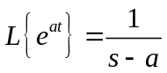 | L1 | CO1 | [2M]
2 | Evaluate  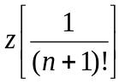 | L5 | CO2 | [2M]
3 | Find the Fourier sine transform of 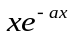 | L3 | CO3 | [2M]
4 | Write Simpson’s 3 / 8 th Rule | L1 | CO4 | [2M]
5 | Write Newton’s backward difference interpolation formula. | L1 | CO5 | [2M]
6 | Evaluate by Euler’s method,y1 = x + y, y(0) = 1 and find y(0.3). | L5 | CO6 | [2M]
7 | Find the Laplace transforms of  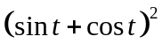 | L1 | CO1 | [2M]
8 | Define Fourier cosine transform | L1 | CO3 | [2M]
9 | Write Milne’s predictor –corrector method formula | L1 | CO5 | [2M]
10 | Define first shifting property in Laplace transform | L1 | CO6 | [2M]
Part – B Max.Marks:50
ANSWER ANY FIVE QUESTIONS. EACH QUESTION CARRIES 10 MARKS.

 |  |  | BCLL | CO(s) | Marks
11. | a) | Find  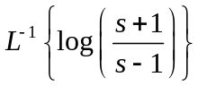 | L5 | CO1 | [5M]
 | b) | Using the convolution theorem find  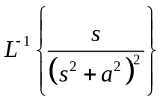 | L3 | CO1 | [5M]
12. | a) | Use convolution theorem to evaluate  z-1  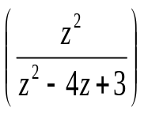 | L3 | CO2 | [5M]
 | b) | Solve the following difference equations by using z- transform  given u(0)=0 and u(1)=1 | L6 | CO2 | [5M]
13. | a) | Find the Fourier cosine transform of  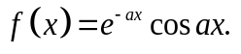 | L5 | CO3 | [5M]
 | b) | Find the Fourier Transform of f(x) defined by 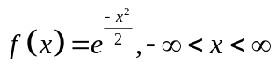 | L5 | CO3 | [5M]
14. | a) | Find a root of the equation 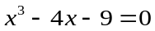 using bisection method | L3 | CO4 | [5M]
 | b) | Evaluate  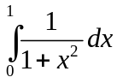 using taking 5 sub internals & by using trapezoidal rule | L5 | CO4 | [5M]
15. | a) | The population of a town in the decimal census was given below. Estimate the population for the 1895 | L3 | CO5 | [5M]
  Year x | 1891 | 1901 | 1911 | 1921 | 1931
  Population of y | 46 | 66 | 81 | 93 | 101
 | b) | Using lagrange formula calculate  f(3) from the following table | L3 | CO5 | [5M]
  x | 0 | 1 | 2 | 4 | 5 | 6
  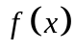 | 1 | 14 | 15 | 5 | 6 | 19
16. | a) | Evaluate y¹= x² – y, y(0) = 1 using Taylor’s series method and find y(0.1), y(0.2). | L5 | CO6 | [5M]
 | b) | Using Runge-Kutta fourth order find y(0.1), y(0.2) given  y¹= x – y and y(0) = 1 | L3 | CO6 | [5M]
17. | a) | Find | L5 | CO1 | [4M]
 | b) | Find the z- transform of  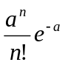 | L5 | CO2 | [3M]
 | c) | Find the Fourier sine transform of  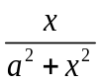 | L5 | CO3 | [3M]
18. | a) | Using Newton’s Raphson method, the real root of the equation correct to three decimal places. | L3 | CO4 | [4M]
 | b) | Find the missing term in the following data | L3 | CO5 | [3M]
  x | 0 | 1 | 2 | 3 | 4
  y | 1 | 3 | 9 | - | 81
 | c) | Find an approximate value of y for x=0.2, if  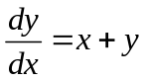 and y=1 at x=0 using Picard’s method. | L3 | CO6 | [3M]
-- 00 -- 00 –

